Editors - Properties Editor
Properties Editor 1
Header and Tabs 1
Editortype Menu 1
Navigation Tabs 1
Tabs position 1
Tools Section 2
Globals section 2
Object Data Section 2

Properties Editor

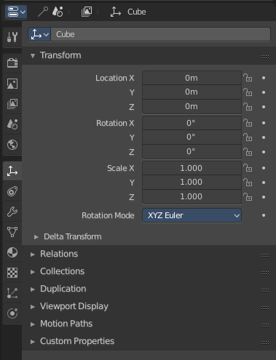
The Properties Editor is the core to manage the data in Bforartists. It is used to edit data and properties for the Active Scene and the Active Object. It contains Scene and Object related settings and properties. It contains all the tool settings for the current active tool. And it contains global settings and properties, like Rendersettings. Materials, particle settings. etc.
The Properties editor is divided into several tabs. And the tabs are divided into several panels. The tabs buttons can be found in the header.
Various content just appears when you are in the right context. Means when you have a specific object type selected, are in a specific mode, etc.

Header and Tabs

The header contains the Editortype menu, and a bread crumb made of icons and text to show where you are in the tabs.

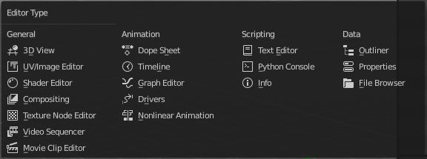
Editortype Menu
The button at the very left shows the Editortype Menu. Here you can switch to another editor type.

Navigation Tabs
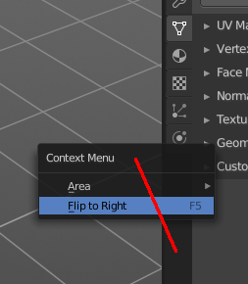
The navigation tabs to navigate in the Properties Editor are vertically aligned besides the editor.

Tabs position
The tabs can be displayed at the left or at the right side. Either click right in the empty space of the tab area. This will bring up the Context menu where you can flip the whole tabs menu bar to the right or to the left. Or move with the mouse over the area and press F5.
The navigation tabs are divided into three groups.

Tools Section
The tools section is just one tab. It contains the settings and options for the currently selected tool. This panels and settings are described in the chapters where the tools are described.
Note that all this options and settings are also available in the global header. It is one big double menu entry. We might remove either the one or the other.


Globals section
The Globals section contains everything that is not related to the currently selected object. But global. Rendersettings, View-, Scene- and Worldsettings.

Object Data Section
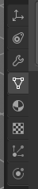
The Object Data section contains everything that is related to the currently selected object. From mesh data across material up to texture and particle system.
The content differs, dependant of the currently active object. For an Armature you will have other tabs than for a Mesh object, and other tabs for a Lattice object for example.
There are some general tabs though for all object types. Like Object, Constraints, Texture, or Physics tab.
We will cover the different tabs in the Object Data section of the manual.

